**Install Python**

- Google “ download python”

- open “ [https://www.python.org/downloads/”](https://www.python.org/downloads/\”)

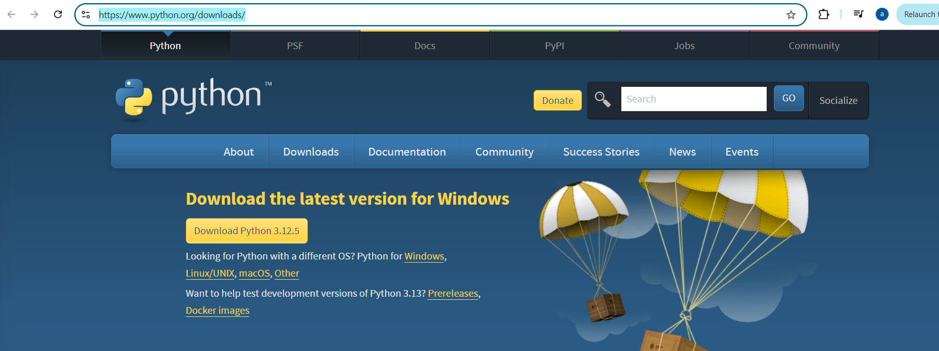

- download python according to the operating system

- run the installer

- choose the option “ set python path” during installation

- once completed

- Run cmd and write python

**Jupyter Notebook on cloud**

- Run “ [https://jupyter.org/try-jupyter/lab/”](https://jupyter.org/try-jupyter/lab/\”)

**Golab Jupyter Notebook**

- This requires gmail account

-https://colab.research.google.com/notebook